Department for Constitutional Affairs
Court Service

SUPS Caseman Printing Proposal


Reference: SUPS-WP-Printing
Version 0.1

15/03/2005



DOCUMENT AUTHORISATION

DOCUMENT TITLE | Department for Constitutional Affairs
DOCUMENT REFERENCE | ISSUE | DATE
SUPS-WP-Printing | 0.1 | 15/03/2005

 | NAME | SIGNATURE | DATE
AUTHORS | Nick Wilson | Electronic
REVIEWERS |  | Electronic
AUTHORISED BY |  | Electronic

CONTENTS PAGE
1 Introduction 5
1.1 Purpose 5
1.2 Intended audience 5
1.3 Scope 5
1.4 Definitions, Acronyms and Abbreviations 5
2 Development Environment 6
2.1 CVS REPOSITORY 6
2.2 JAVA 1.4.2 6
2.3 Eclipse 3.0 7
2.4 Microsoft Internet Explorer 6.0 Service pack 1 11
2.5 Microsoft Script Debugger 11
2.6 Mozilla 1.7 11
2.7 Othet tools 11
3 Troubleshooting 12
3.1 Eclipse 12

External References
Reference | Title | Version | Date

Introduction

Purpose
This document provides a recommendation by the SUPS Caseman Word Processing team for the printing of notices, orders, judgments and warrants to the users printer. It details the proposed technical solution and addresses any dependencies and security issues.

Intended audience
The primary audience for this document are the SUPS project management team and developers working on the various SUPS applications.

Scope
This document includes the operation of the proposed printing solution on both the client and server as well as dependencies and requirements placed on the SUPS server and the client Link machines. It does not cover installation of required software on client and server machines.

Definitions, Acronyms and Abbreviations
Term | Definition
JRE | Java Runtime Environment
JDK | Java Development Kit

Printing Solution

Requirements

Printing Architecture

Link Clients
SUPS Server
Link Printer
Xerox Phaser 4500 PS
SUPS Caseman Application
Standard Link Build PCs

Printing Design
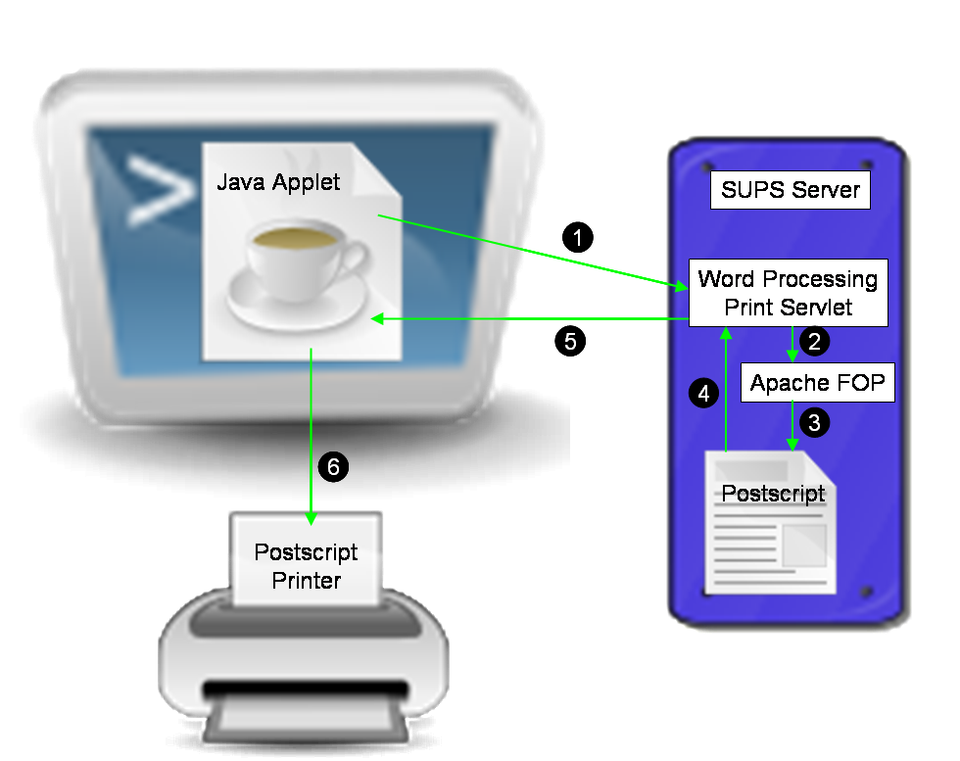

 | Word Processing Printing Steps
1 | The Java applet sends an HTTP request to the Word Processing Print Servlet passing an ID number to identify the required print job as stored in the database.
2 | The Word Processing Servlet loads the necessary data from the database and invokes Apache FOP to generate the appropriate documents for the job.
3 | Apache FOP renders the requested print job to Postscript.
4 | The Postcript file is streamed back out through the servlet. As this happens, control commands are inserted in the postscript to set the simplex/duplex mode on the printer.
5 | The Postscript is streamed back to the Java Applet.
6 | The Java applet creates a print job on the clients default printer and streams the Postscript data directly to the printer.

Software Dependencies

Client
The Link client machines will require the Sun Java 1.4 Runtime Environment with the Java Plugin enabled to allow the Java Applet to run in the client browser.

Server
There are no additional requirements placed on the SUPS server.

Security
With the JRE installed Java Applets will run inside the Plugin’s ‘sandbox’ which enforces tight security controls on the Applet preventing it from executing any unauthorised code. Printing from the Applet can still be accomplished by one of the following methods.

User Confirmation
In this scenario a standard unsigned Java Applet is used. As it creates the print job, a pop-up dialog is presented to the user asking them for confirmation.
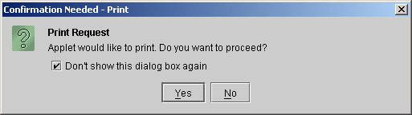
Clicking Yes on the dialog will allow the application to send the print job to the printer.

Signed Applets
In order to avoid asking the user for confirmation of printing and allow print jobs to be seamlessly streamed to the user’s printer, it is necessary to used a signed Java Applet. The first time this applet is loaded, the user will be shown the following dialog box.
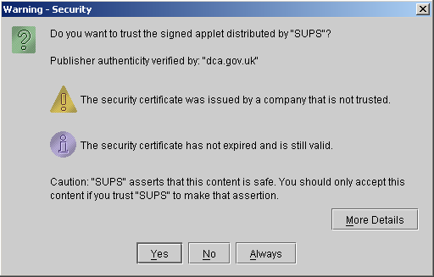
Clicking Always on this dialog will enable the applet to send print jobs to the users printer without any user interaction. The certificate used to sign the applet is stored on the client machine and the applet retains permission to access the printer for as long as this certificate is valid.

Using a Trusted Certificate
The dialog in the previous section contains the warning message ‘The security certificate was issued by a company that is not trusted.’. This warning message can be removed by signing the applet with a certificate that has been issued from a trusted source, such as Verisign or Thawte. The Java JDK documentation contains further details on how this is done.

Locking Down Java Security
By default signed applets are allowed more permissions than just accessing the printer, such as access to the clients file system. These permissions can be restricted by modifying the security policy file in the JRE. The Java JDK documentation contains further details on how this is done.

